**Broccoli Microgreens** have concentrated levels of vitamins A, B complex, C, E, and K, including the minerals calcium, copper, iron, magnesium, phosphorus, potassium and contain elevated levels of compounds that convert to sulforaphane.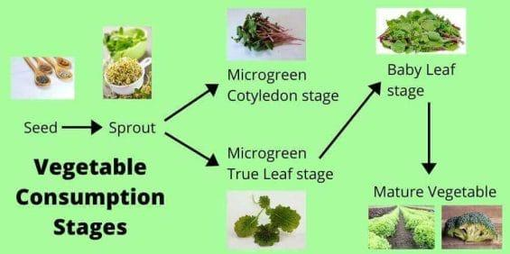

**Sulforaphane** is a phytochemical that may have powerful cancer-fighting and preventative properties.

**Radish Microgreens** are an excellent source of vitamins, including A, C, E, and B complex.

**Pea Shoot Microgreens** have significant amounts of vitamins C, B9, B1, B5, and are rich with the mineral iron, manganese, and choline.

**Sunflower Microgreens** are abundant in Amino Acids and minerals and a fantastic source of vitamins A, B complex, E, K, and are a substantial source of calcium.

**Microgreens** provide many nutritional benefits essential in the body’s processes. Fortifying heart health, boosting the immune system, and aiding in detoxification.

